INTRODUCTION TO MOBILE APPLICATION DEVELOPMENT.
Student Name: Faith Mueni.
Admission Number: BIT/2024/74441.
School/faculty: Computing and informatics.
Programme: Degree
Academic Year: III
Semester: II
Lecturer: Michael Nyoro.
Phone Number: 0722313169

WEEK 1.
Tools used:
Android studio.
Figma
Vs code
Flutter SDK
Android phone

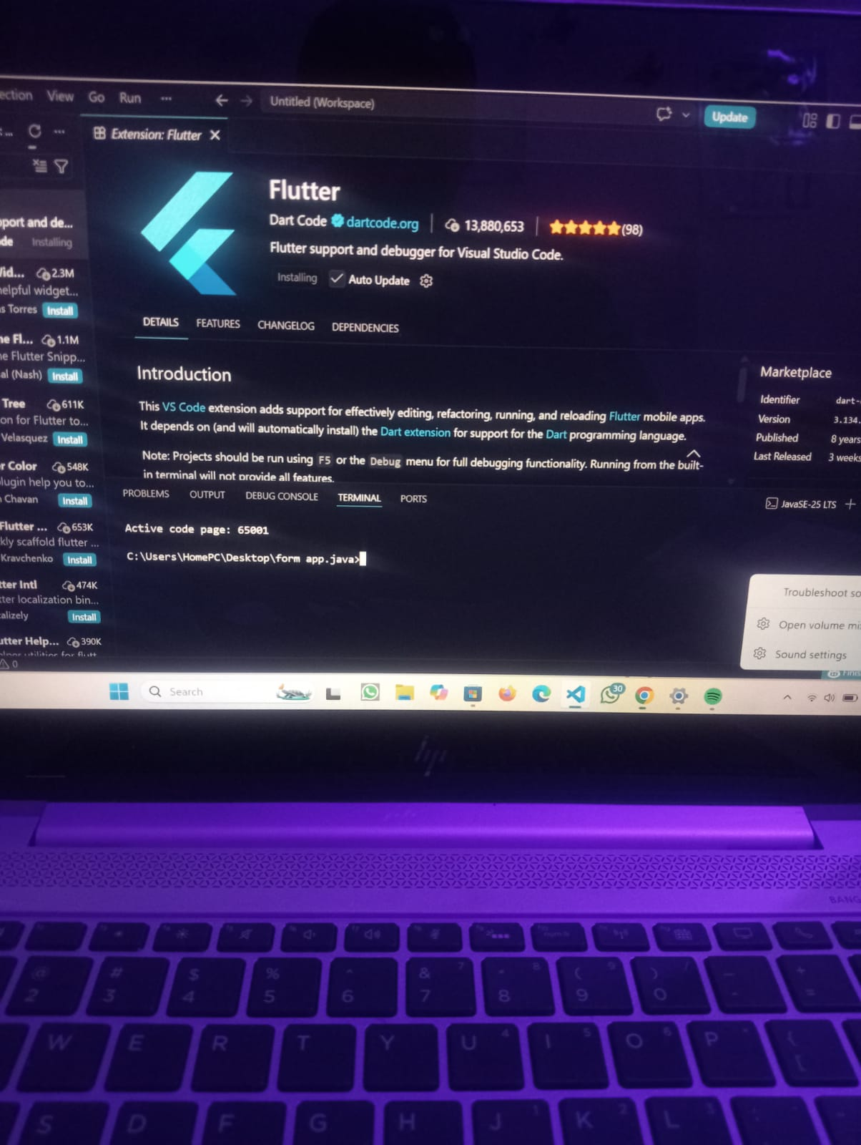

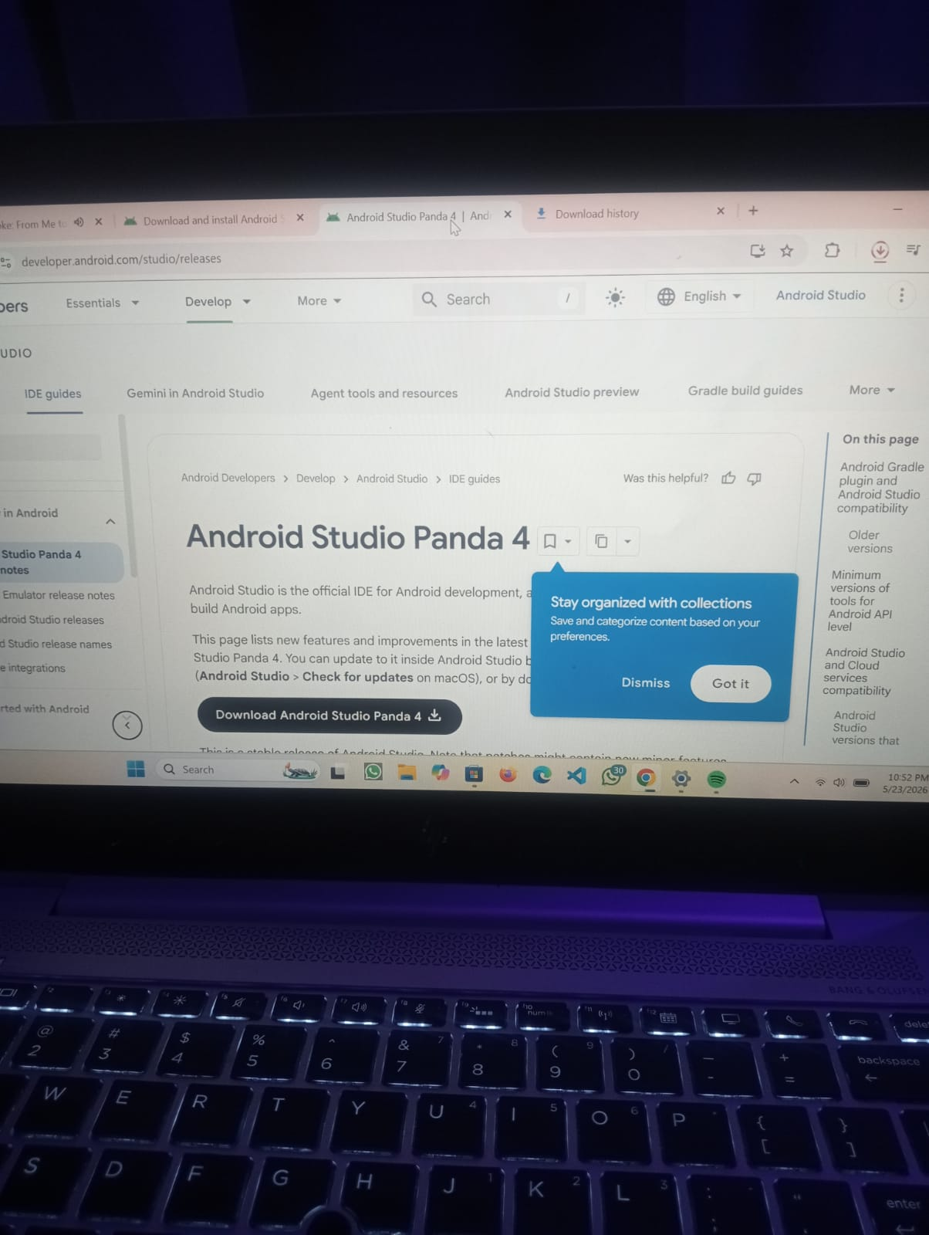

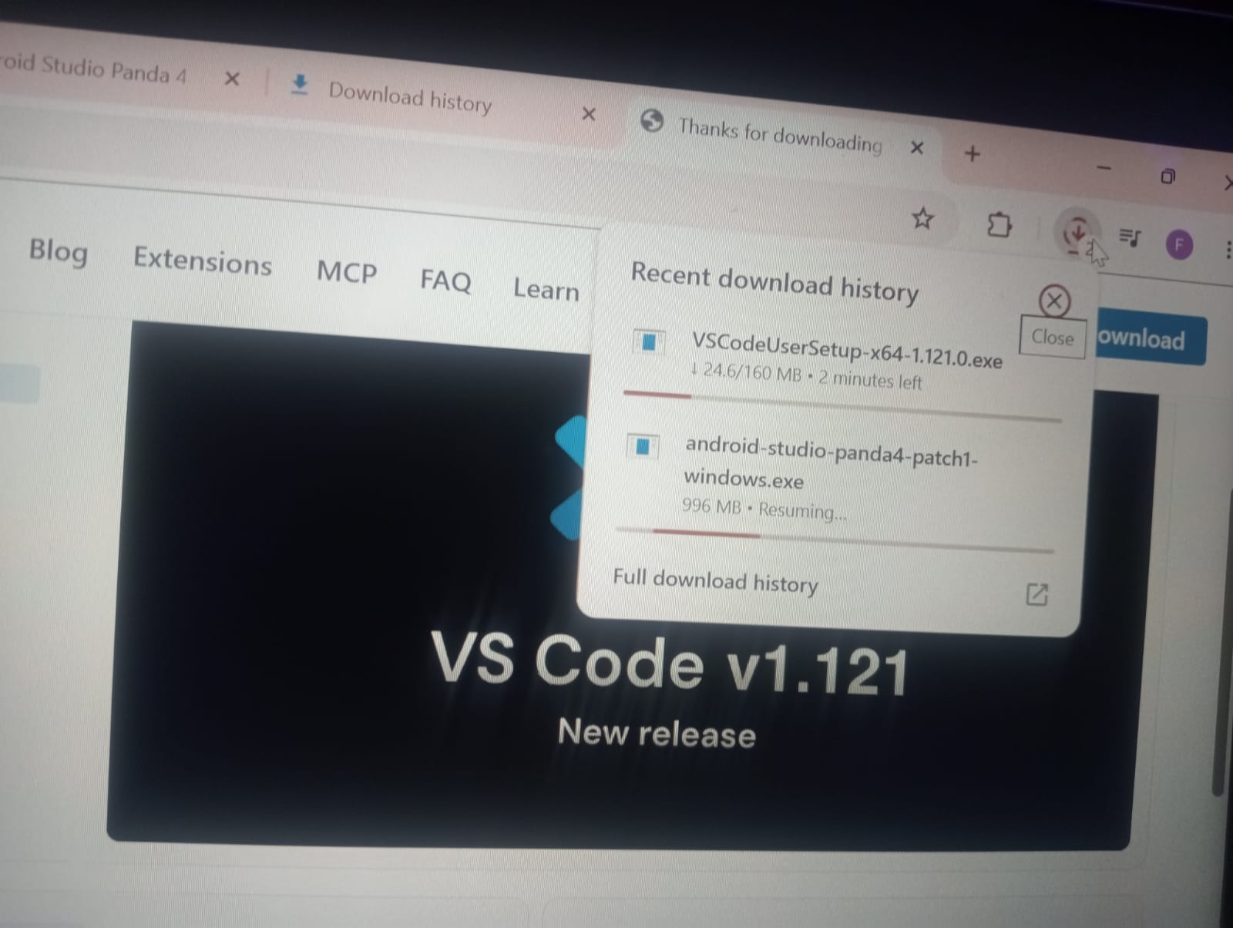

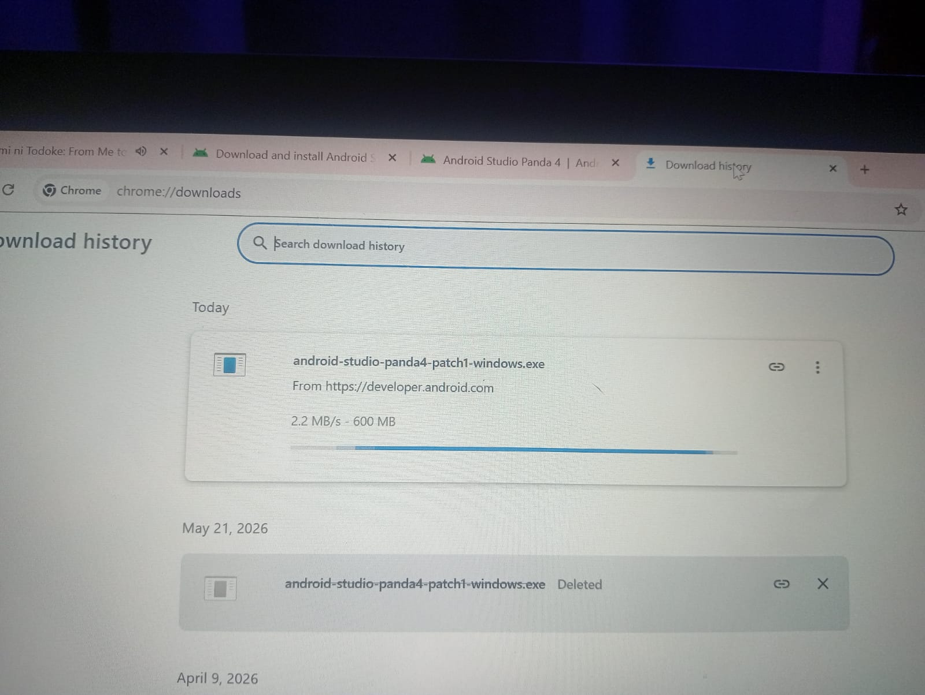

PERSONAL REFLECTION
Installing the tools was challenging at first due to errors and configuration issues, but it improved my problem-solving skills. I gained practical experience in setting up development environments and became more confident in using modern software tools for app development.

WEEK 2: MOBILE DEVELOPMENT ENVIRONMENT.
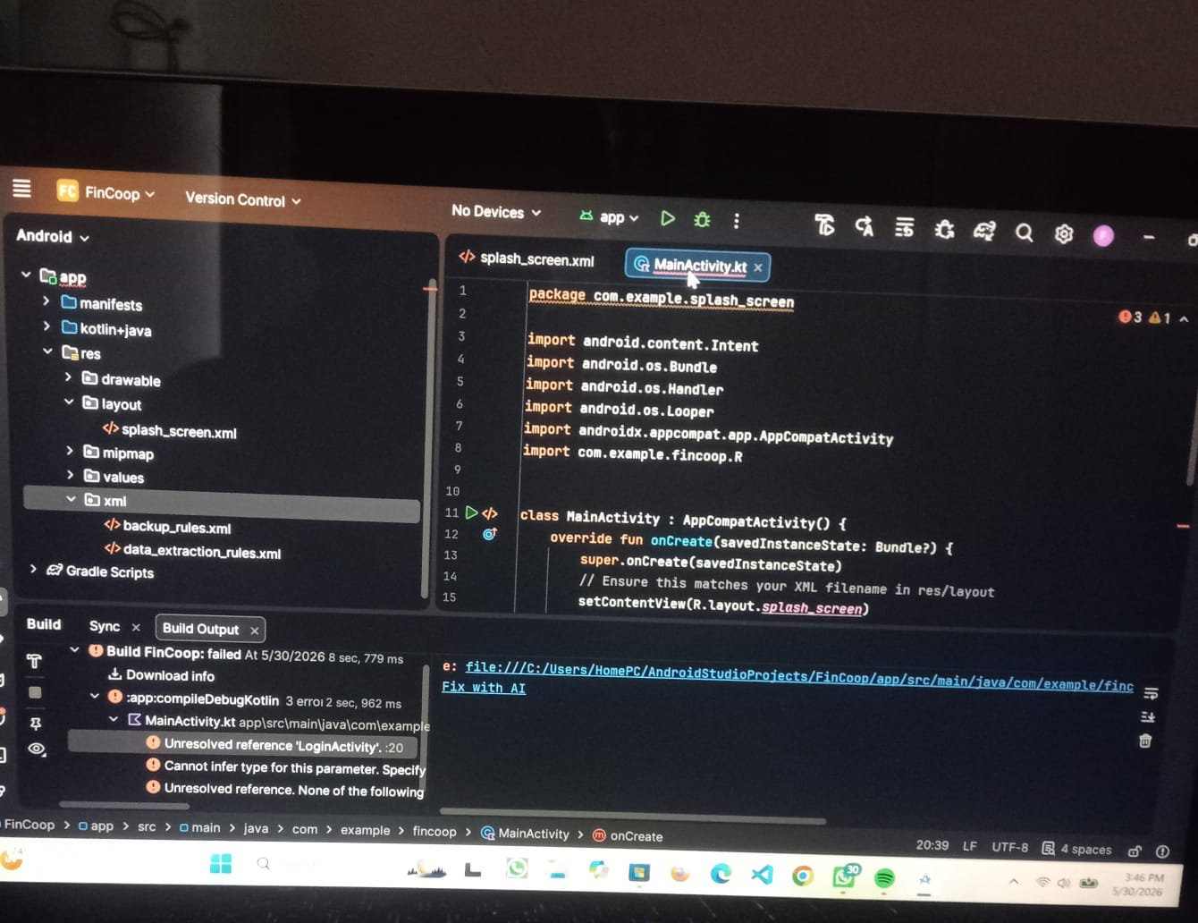

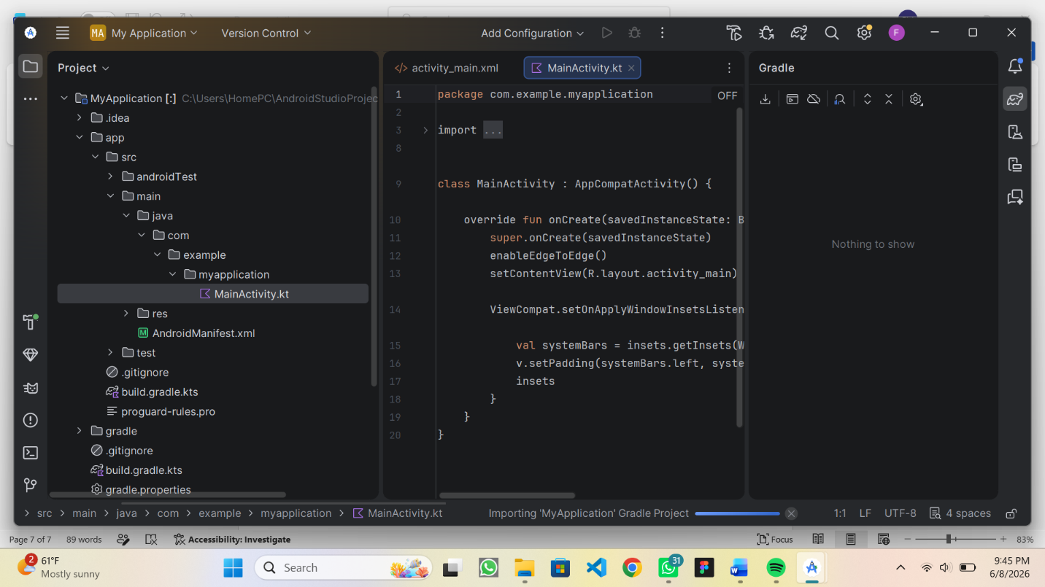

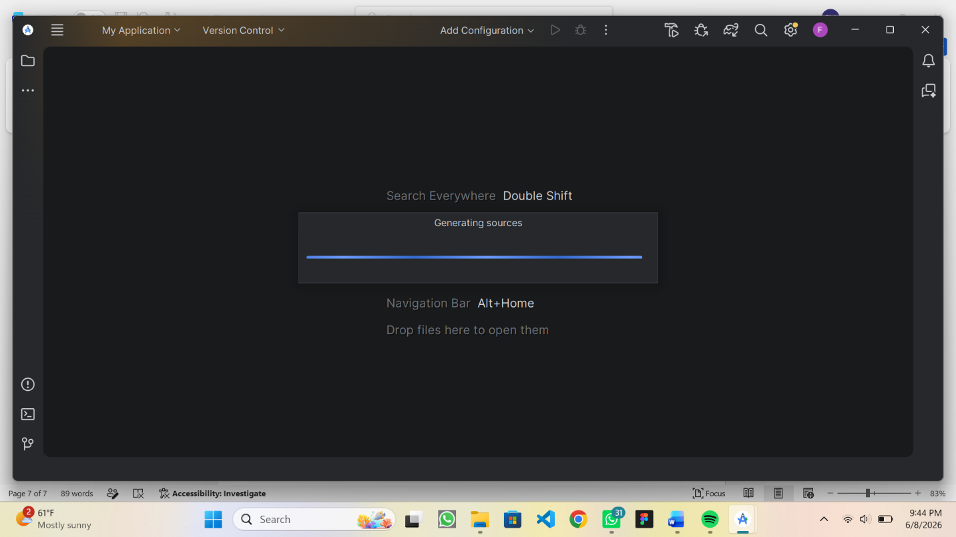

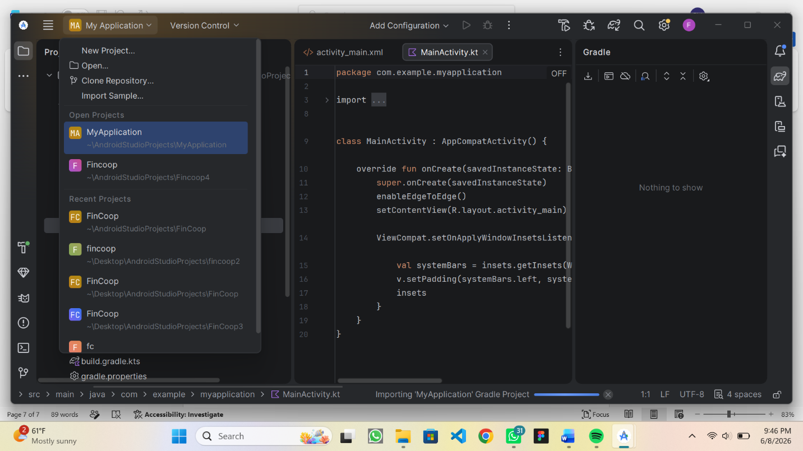

PERSONAL REFLECTION
I set up the mobile development environment by installing and configuring tools like Android Studio, Flutter SDK, and device emulators. This process helped me understand how different components work together, though I faced minor setup challenges that enhanced my troubleshooting and technical skills.

WEEK 3: USER INTERFACE DESIGN
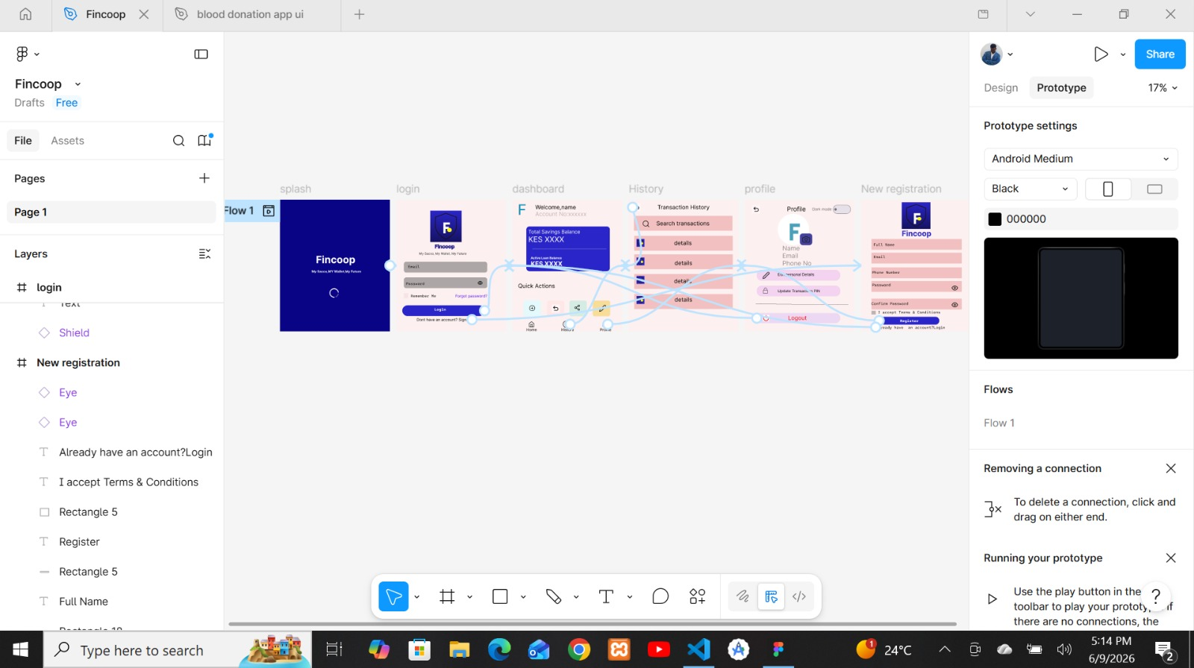

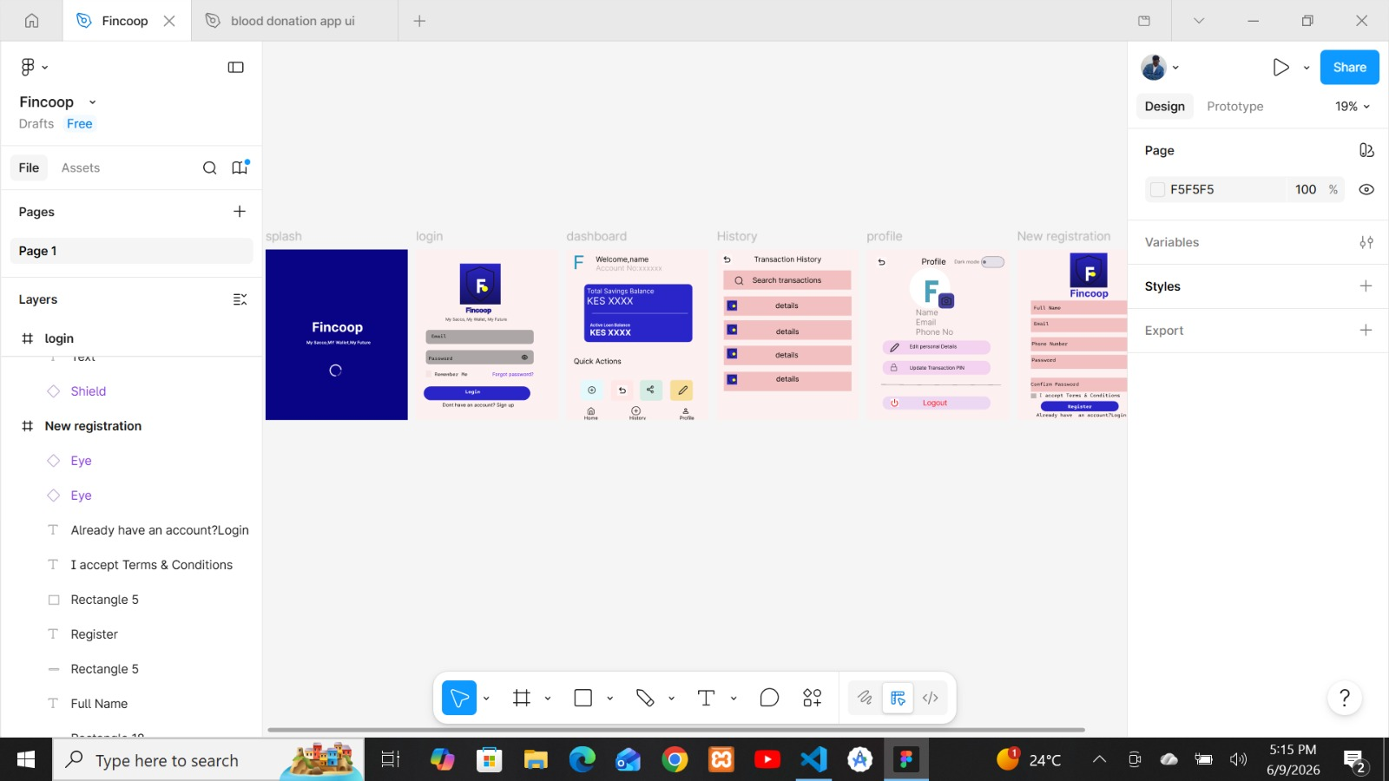

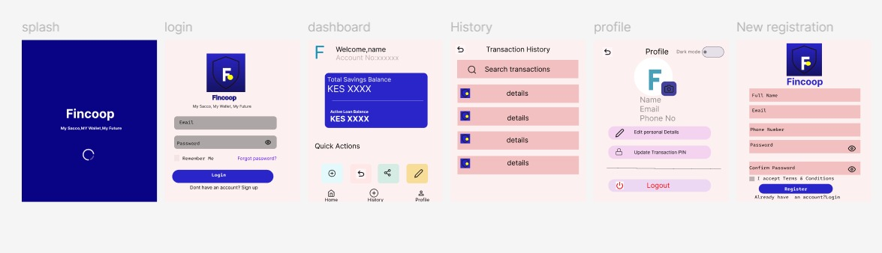

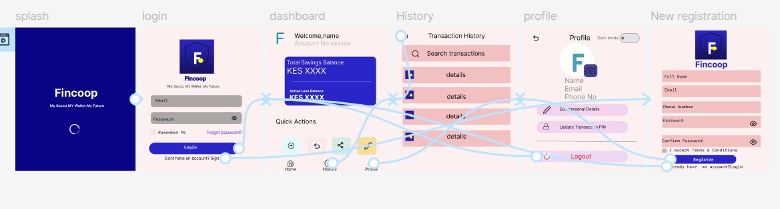

Personal reflection
I focused on user interface design for the blood donation app using Figma. I learned how to create and organize screens, design user-friendly layouts, and improve overall system usability. This improved my understanding of UI/UX principles and enhanced my design skills.

WEEK 4: EVENT HANDLING AND USER INTERACTION.
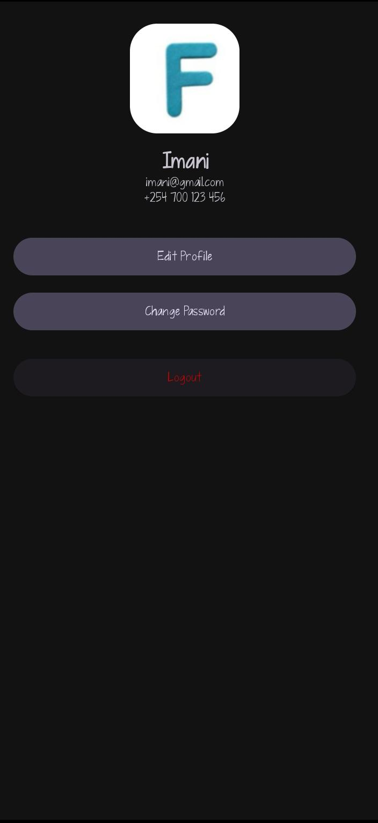

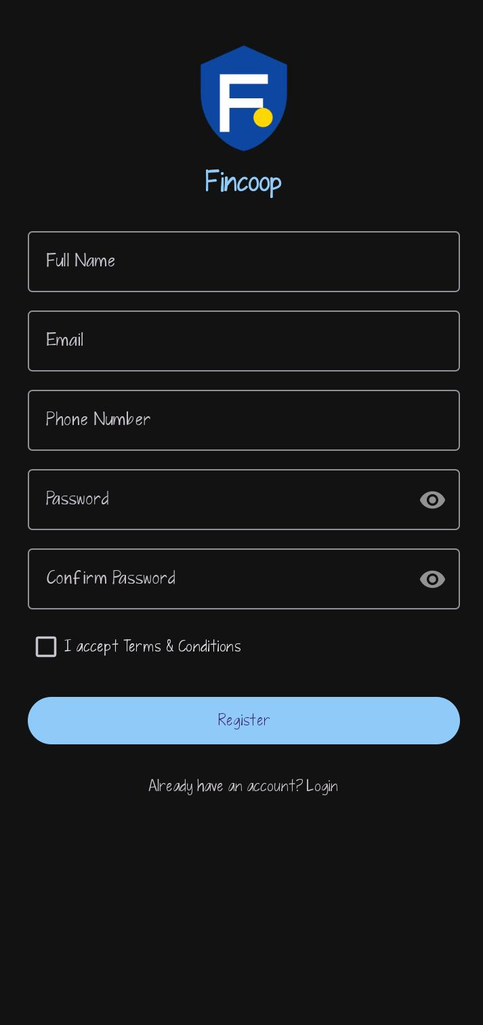
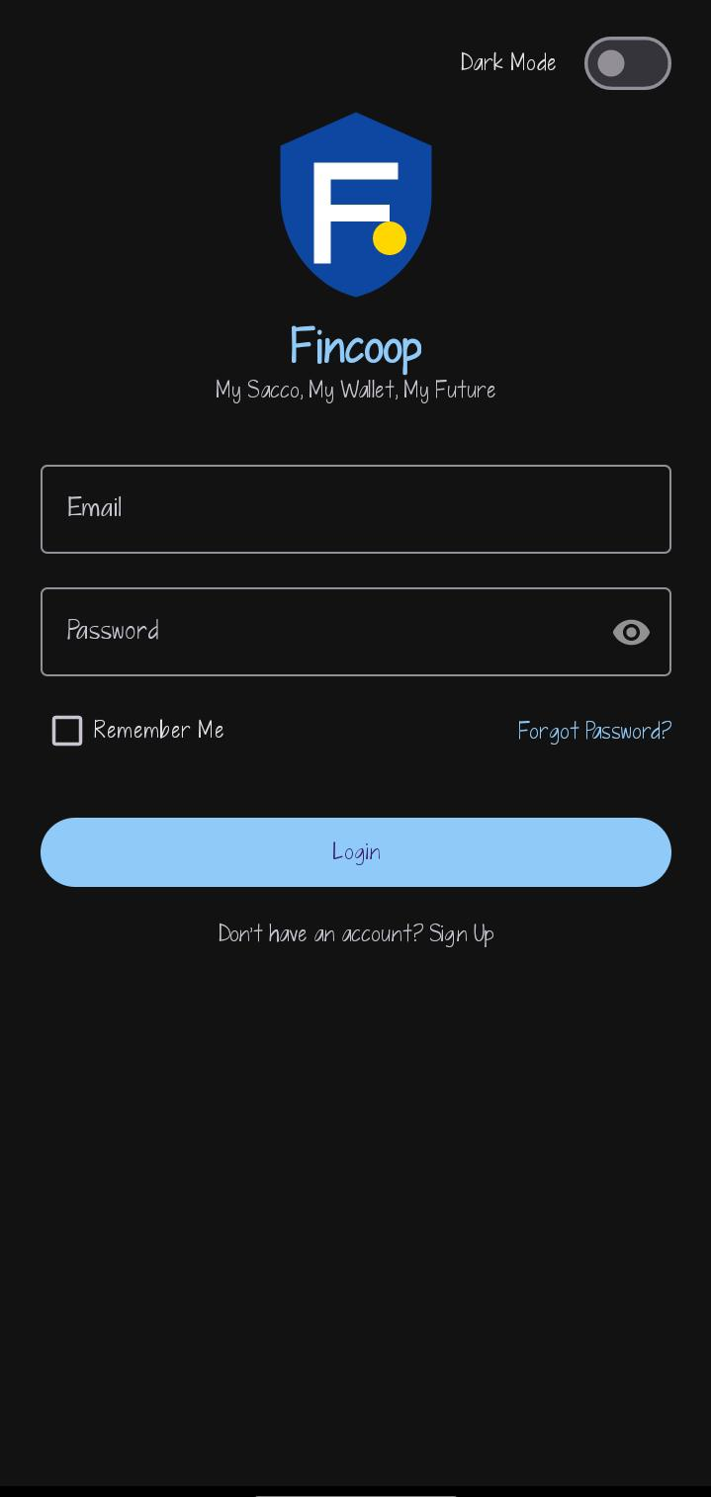
Personal reflection
I learned about event handling and user interaction in the fincoop app. I implemented how users interact with the system through buttons, forms, and input fields. This improved my understanding of how applications respond to user actions and enhanced my programming skills.

WEEK 5 DATA MANAGEMENT.
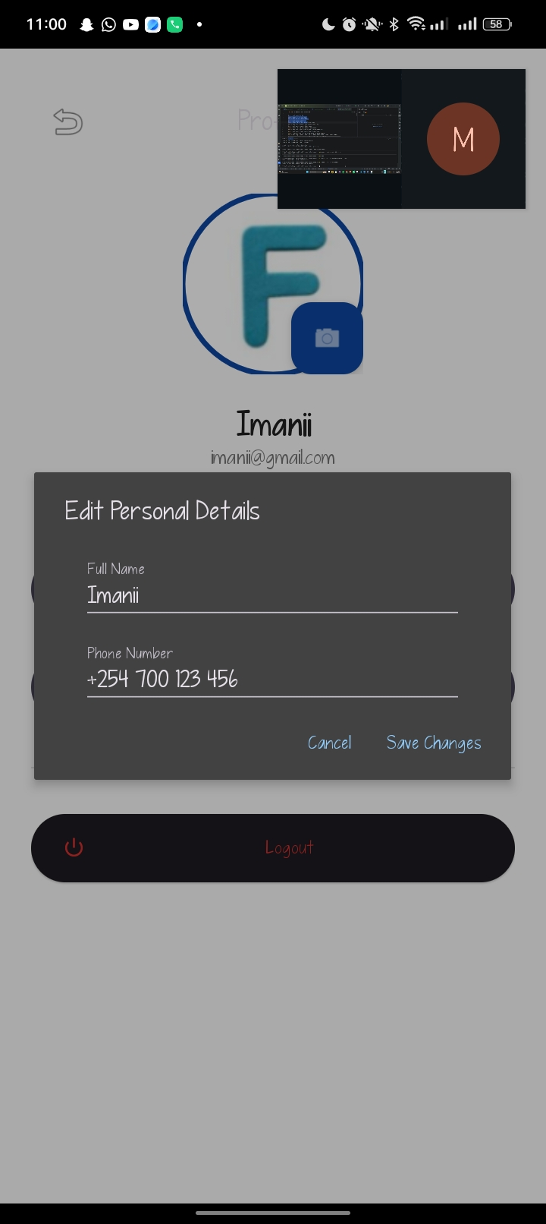

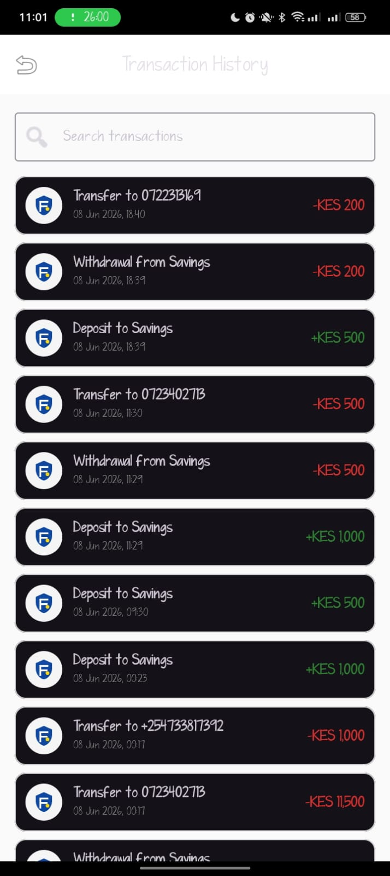
Personal Reflection

I focused on data management in the FinCoop application project. Through this role, I learned how to store, retrieve, update, and manage member information, savings records, loan details, and transaction data using local storage and database systems. This experience enhanced my understanding of database management, data security, and efficient record keeping in financial applications. It also improved my technical skills in handling application data and strengthened my ability to develop reliable systems that support accurate and secure financial operations.

WEEK 6:NETWORKING AND API

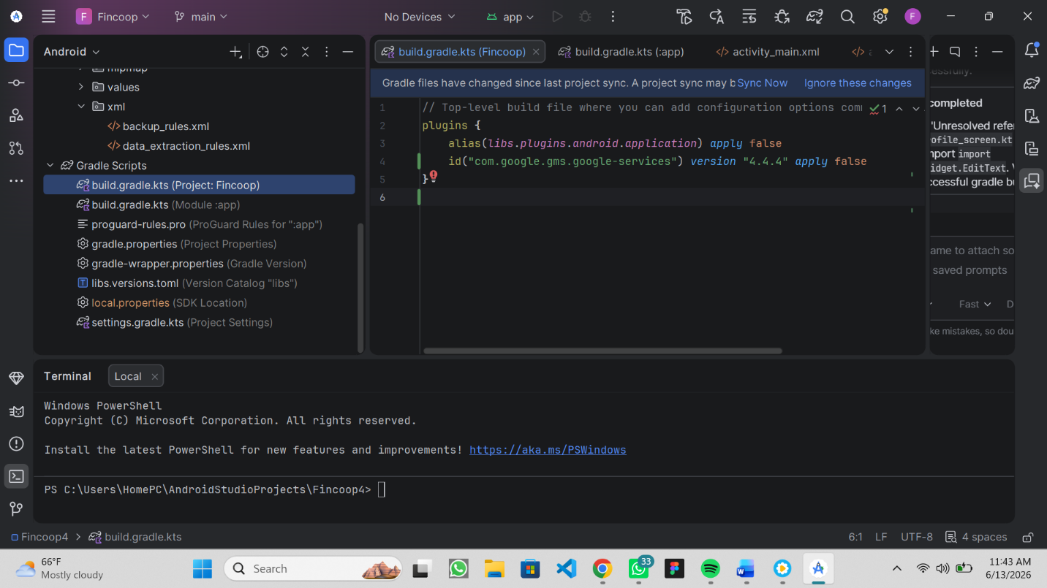

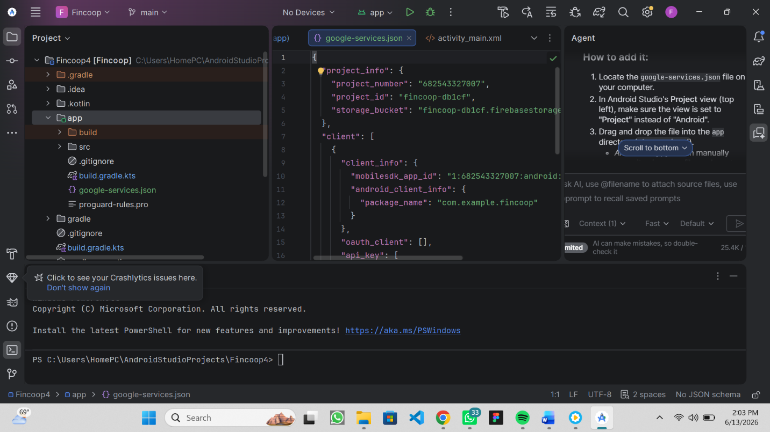

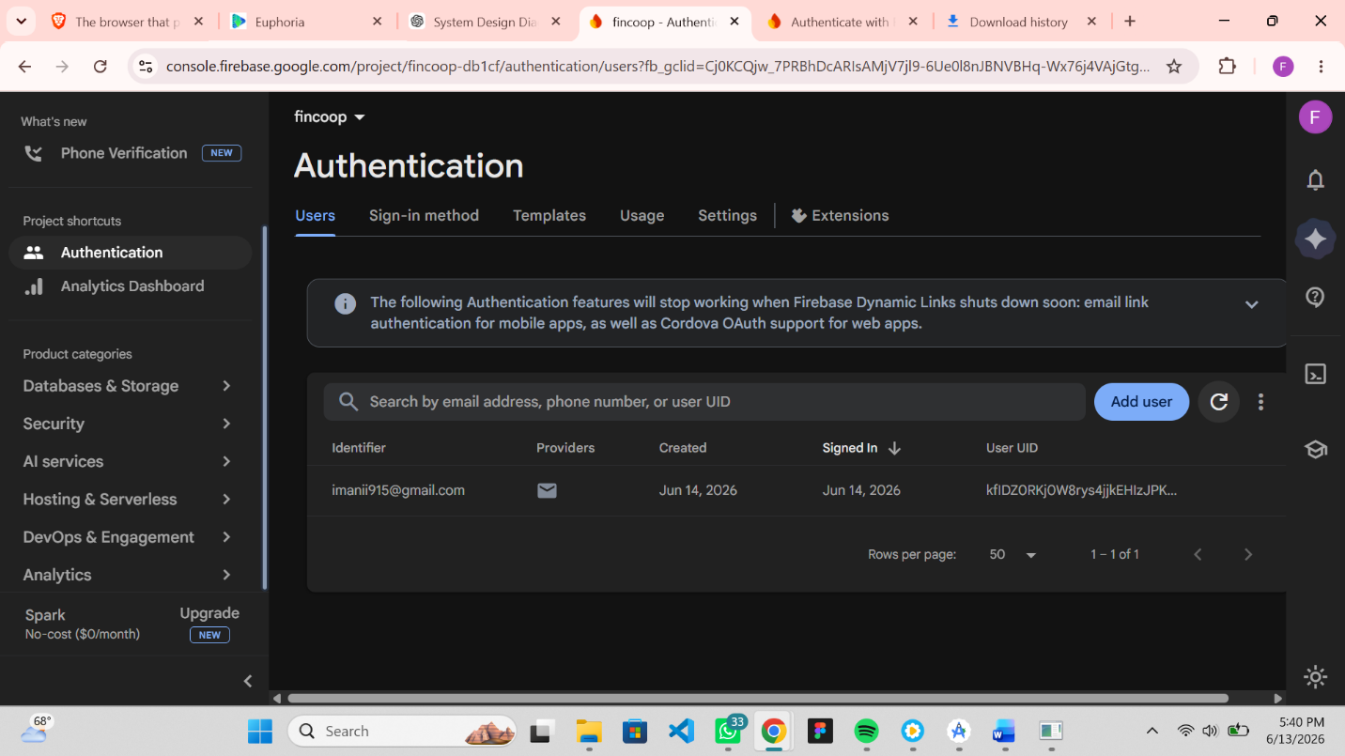

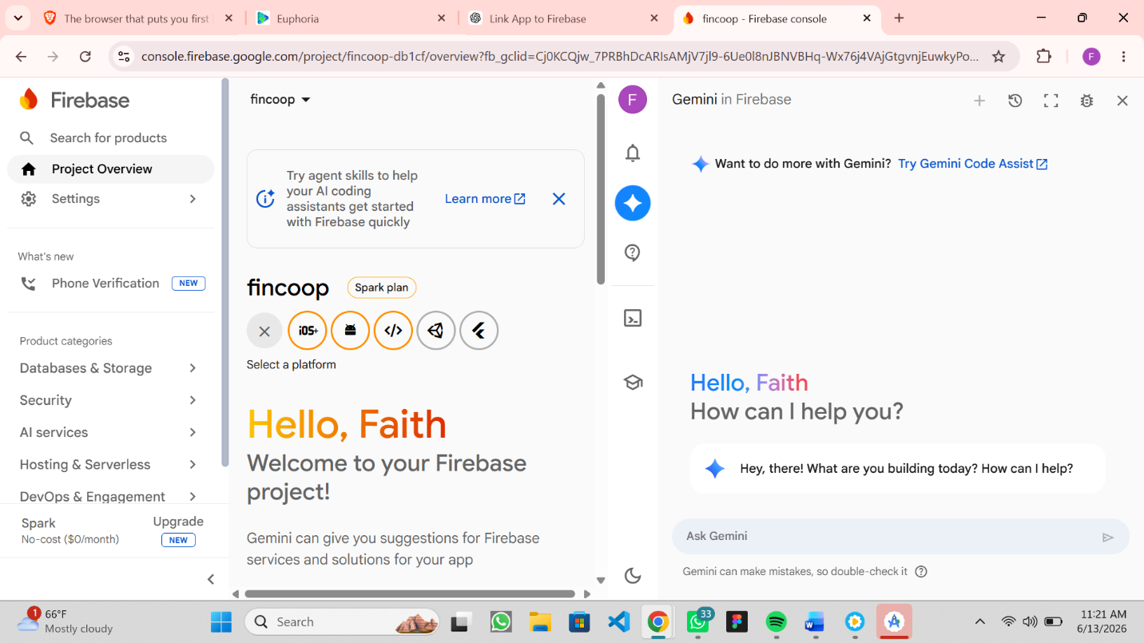

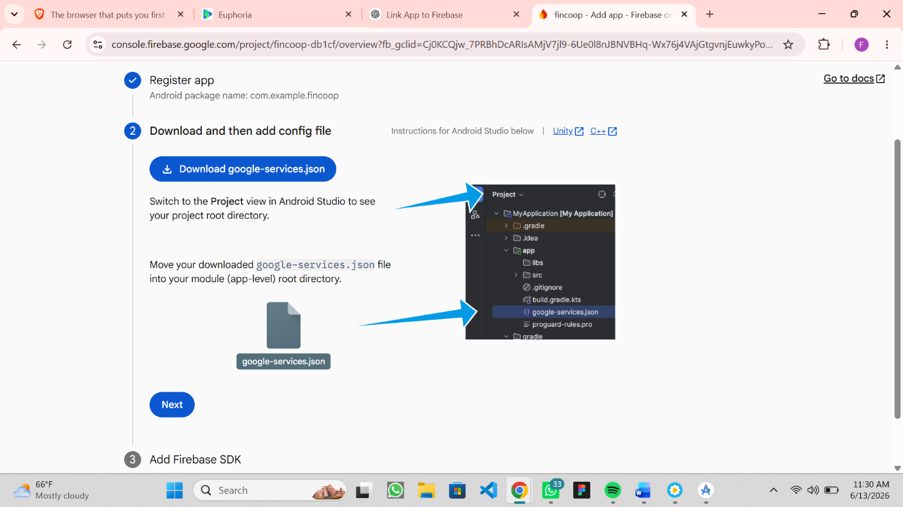

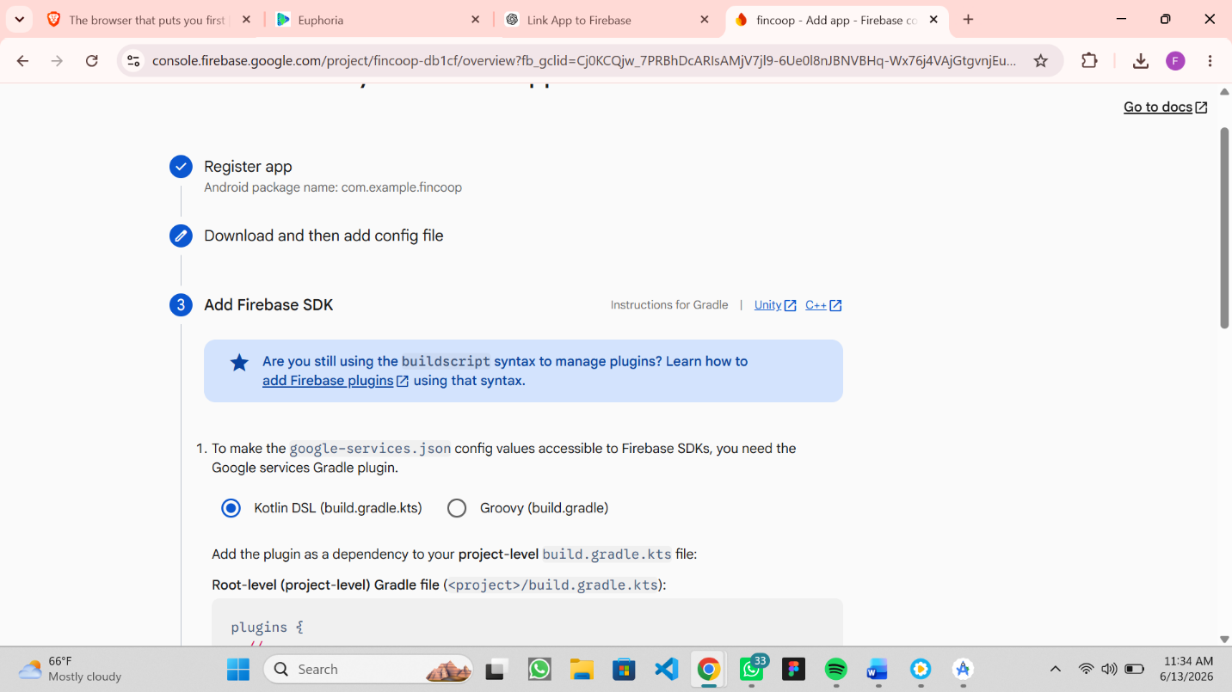

My app requires networking because an app needs networking to exchange data with servers, access online services, synchronize information, and enable real-time communication.

